Assignment 1

Mansoor Zafar
Seneca College
Course Code: DPS955 NSA
Dr. Asad Norouzi
Feb 10, 2025

Table of Contents:
Introduction 1
GitHub Links 2
GitHub Repository 2.1
GitHub CI Links 2.2
Screenshots 3
Conclusion 4

Introduction:
The system that I am building is a cloud based microservice API for managing fragments. This API aims to connect the existing system and subsystems with said fragments in a highly scalable manner. Fragments are defined as any piece of text, as such, this microservice will provide the following: HTTP REST API to existing services, CRUD operations on fragments, fragment conversions and appropriate authorization. This microservice will be developed in GitHub, automatically tested and deployed to AWS.

GitHub Links
Repositories:
Fragments:
https://github.com/MansoorAZafar/fragments
Fragments UI:
https://github.com/MansoorAZafar/fragments-ui
CI Link(s)
https://github.com/MansoorAZafar/fragments/actions/runs/13250188262

Screenshots:
Order:
- CI Workflow all Working
  - ESLint
  - Unit Tests
- Fragments API running on EC2 instance
  - The Terminal showing its running
  - Health Check
  - AWS EC2 URL in the browser
- Fragments UI running on local host authenticating with Amazon Cognito UI
  - Fragments UI running on localhost
  - Amazon Cogito Hosted UI
- Fragments UI running on localhost, creating fragment via HTTP POST, showing dev tools information
  - POST to the API server running EC2
  - Network Response
  - JSON MetaData
- Coverage Report

1: CI Workflow all Working
ESLint
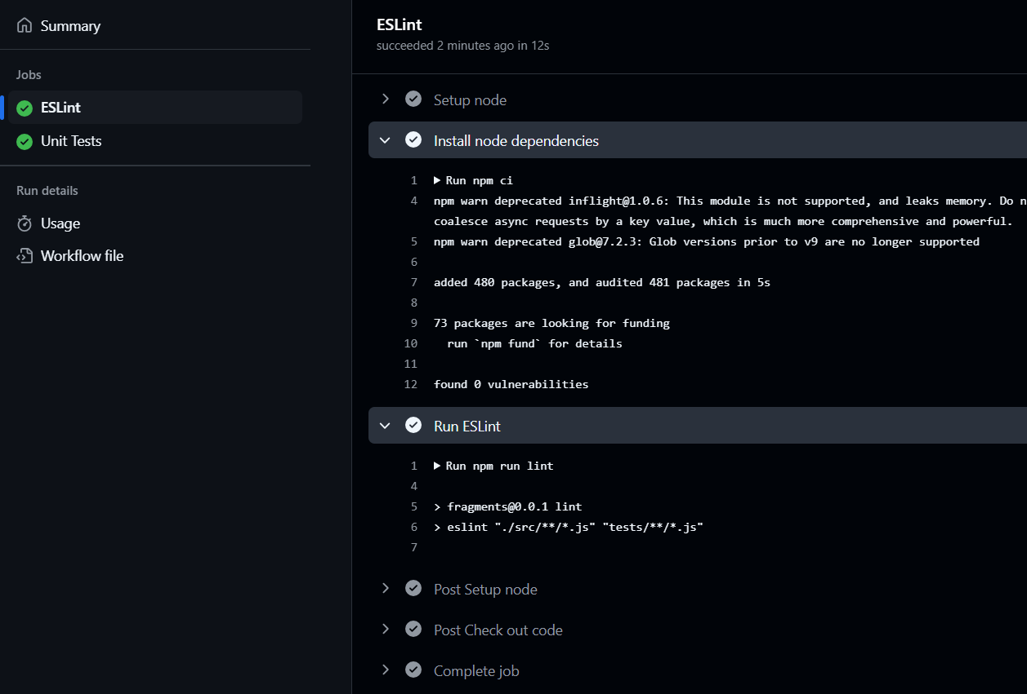
- ESLint was ran on the entire code for the fragments microservice, and it resulted in a pass, meaning no issues and ensured consistency.
UnitTests
- Unit tests covered ~94% (93.96) of the application, they ensure complete functionality of the application. 75 units were run, they consisted of both good and bad cases, where the user input would be valid and scenarios where their input would be bad.
- For example: the code below, shows an example of expecting a bad result due to the client attempting to access an invalid fragment type.
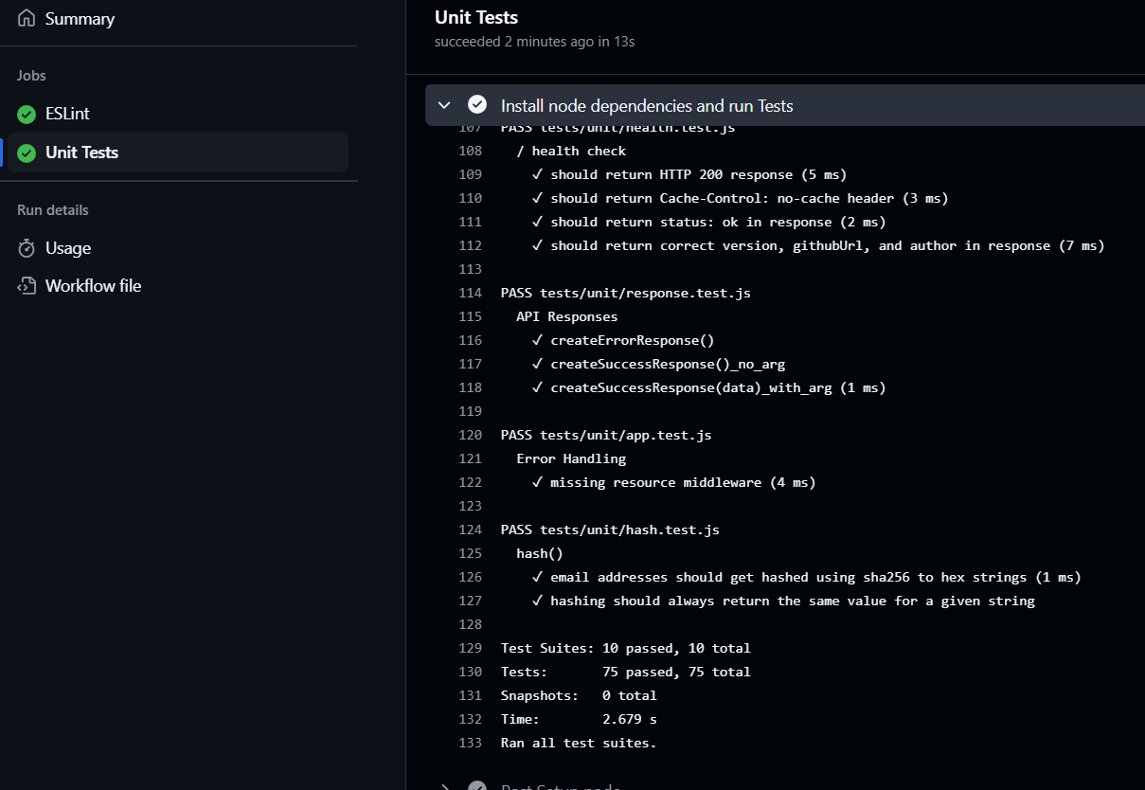
2: Fragments API running on EC2 instance
The Terminal showing its running:
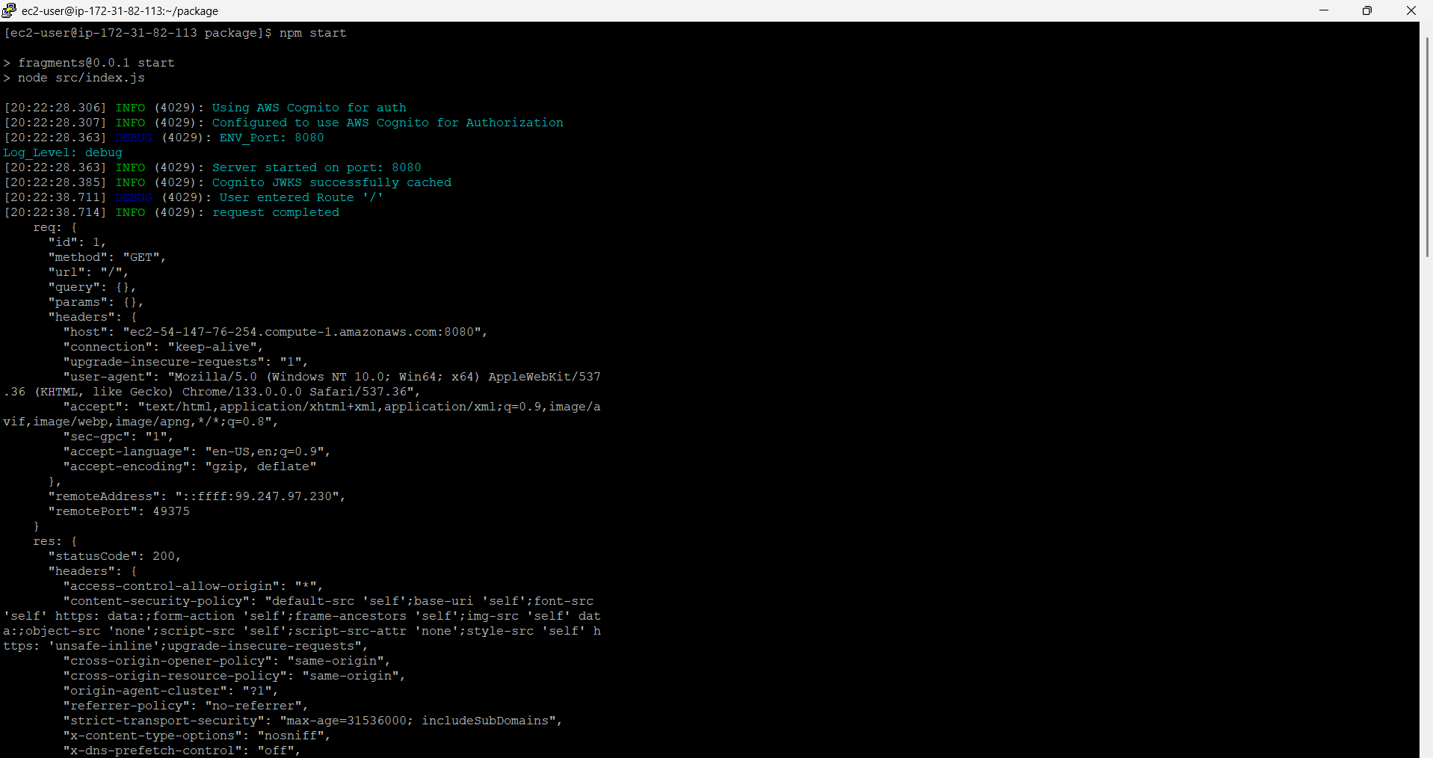
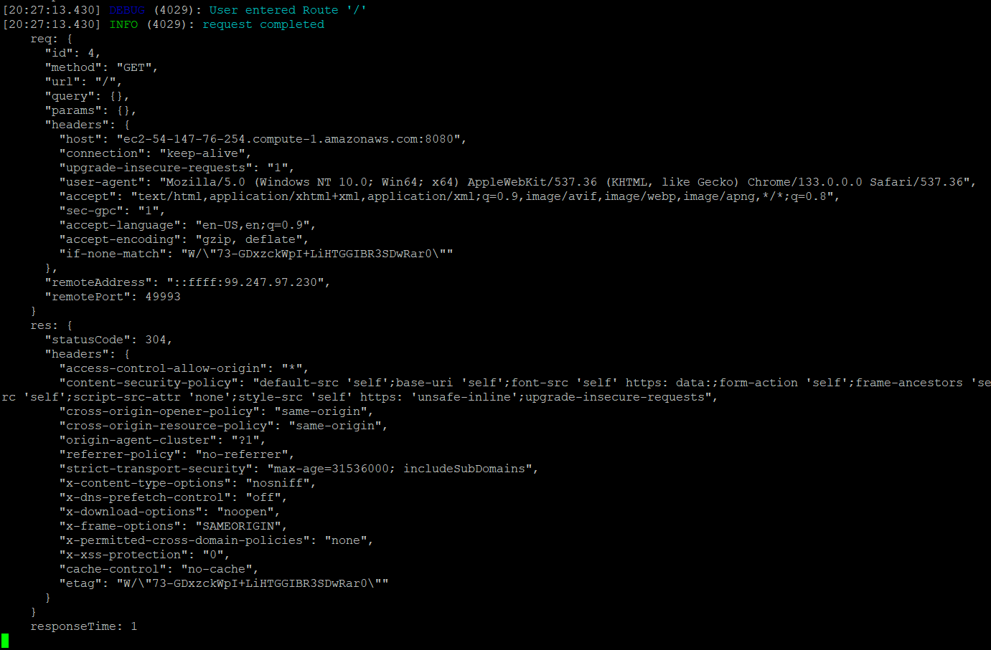
- These images show 2 major aspects
  - The setup being successful, for instance, the log “Using Cognito for Auth”, this simple log tells us that the setup for using cognito as a service for authentication was successful.
  - The root route ‘/’ being successful, it logs the user entering the ‘/’ route and logging that the request was successful.
Health Check:
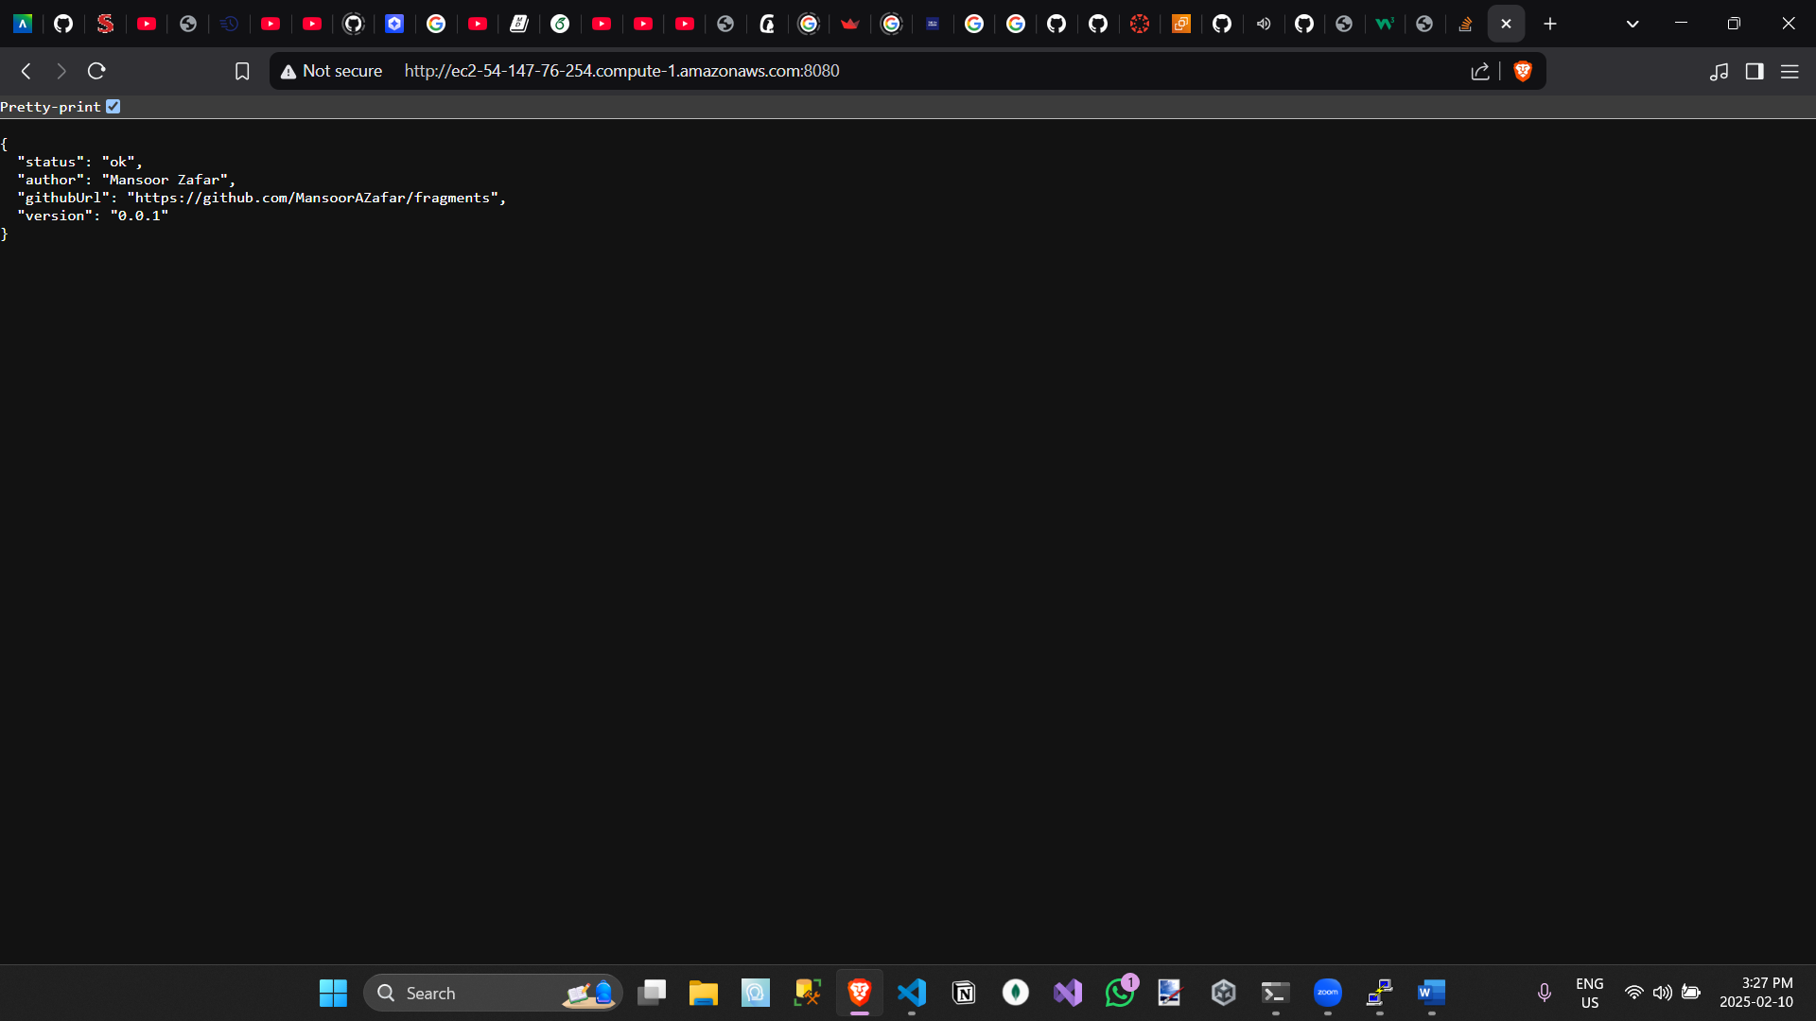
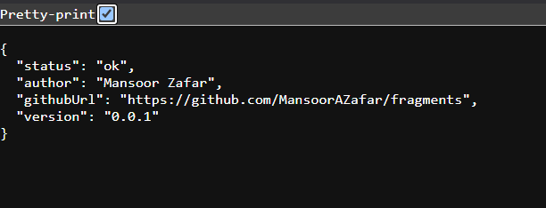
- The health check just returns the ‘health’ of the microservice, and this result is the ‘healthy’ output of 200. Anything else would have been an ‘unhealthy’ result and would need further inspection.
AWS EC2 URL in the browser:
- This is the pubic IPv4 of the EC2 instance, showing its able to run on the web
3: Fragments UI running on local host authenticating with Amazon Cognito UI
Fragments UI running on localhost:
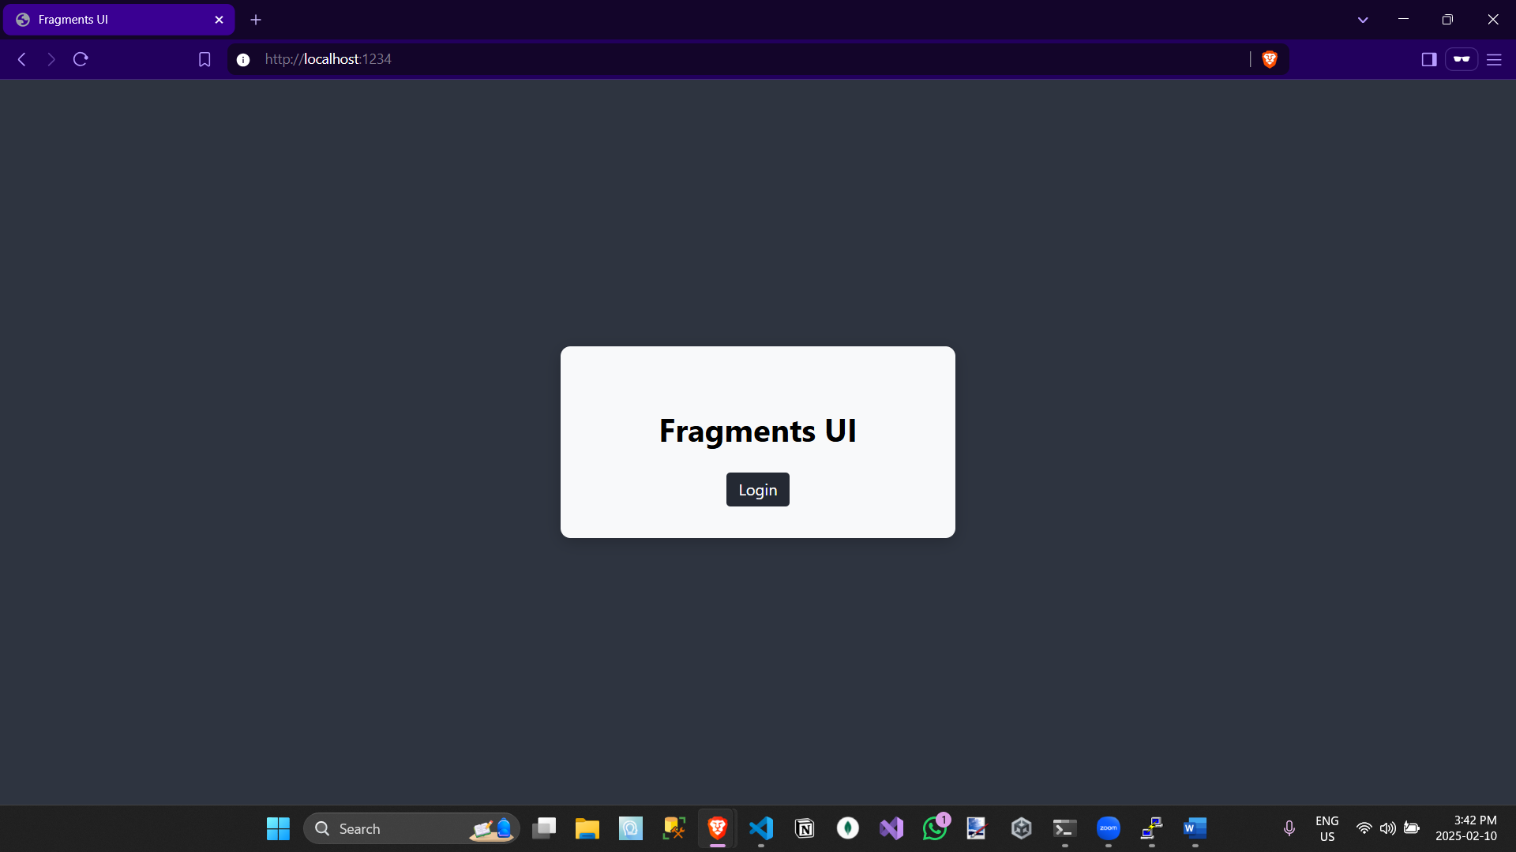
- This image shows the Fragments UI running on localhost (1234)
Amazon Cogito Hosted UI:
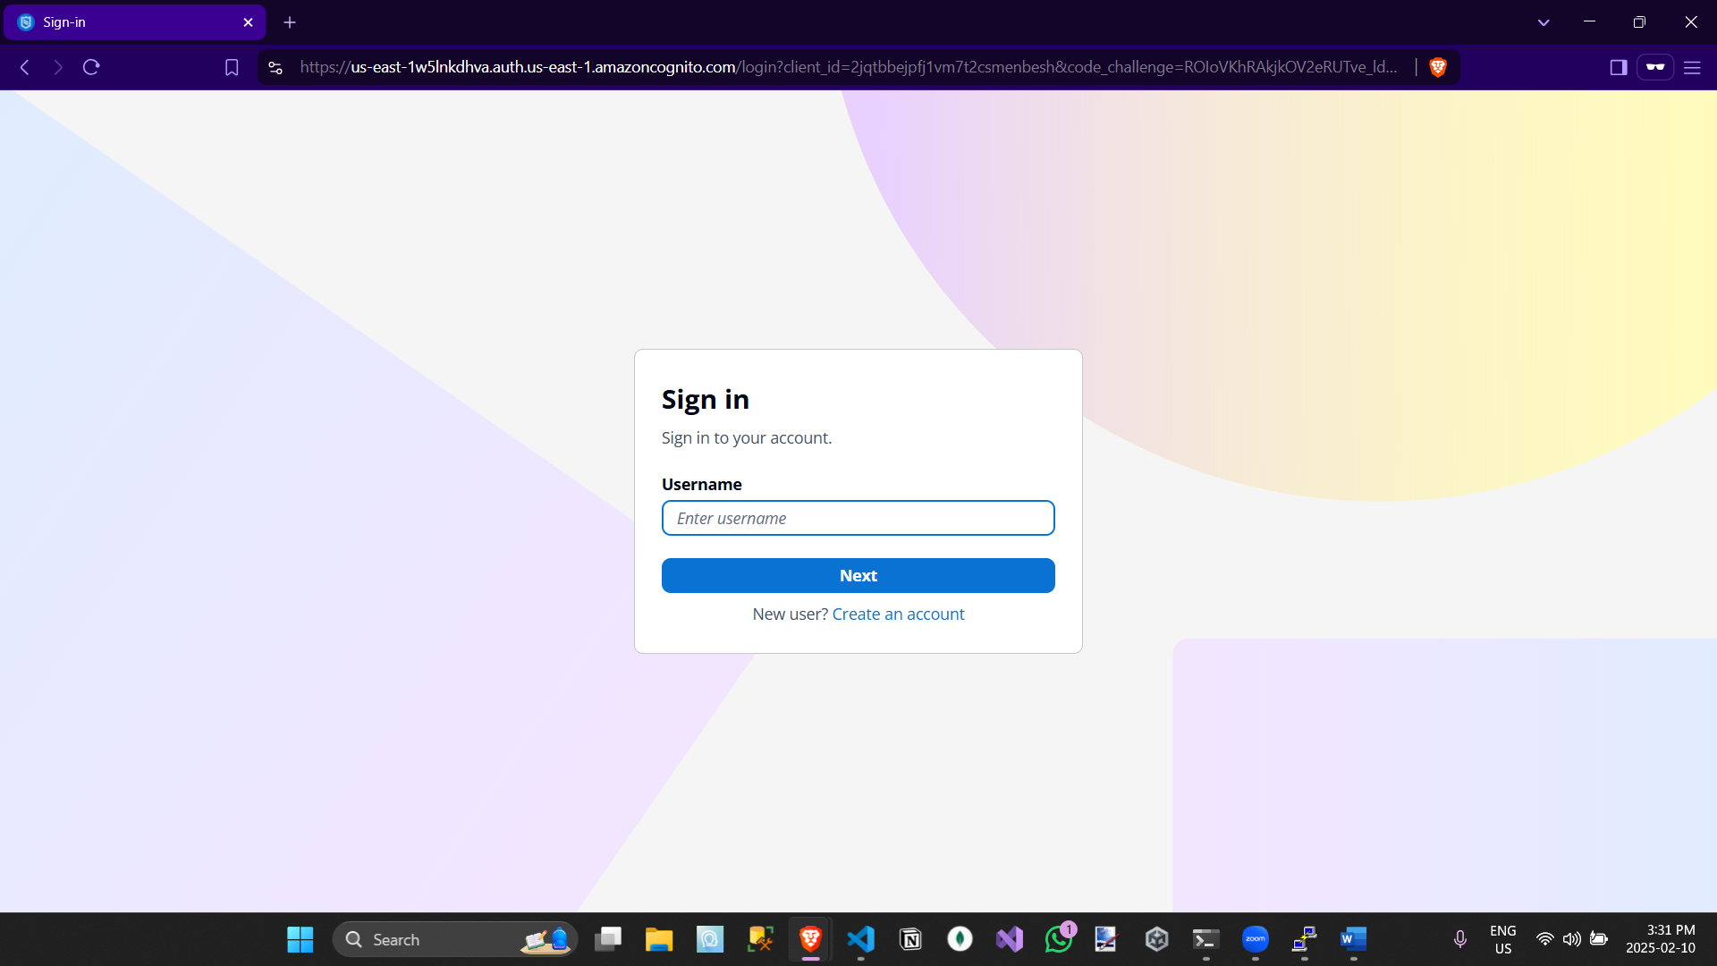
- This shows that after the client presses the <Login> button from the Fragments UI, they are sent to Cognito’s Hosted UI to login
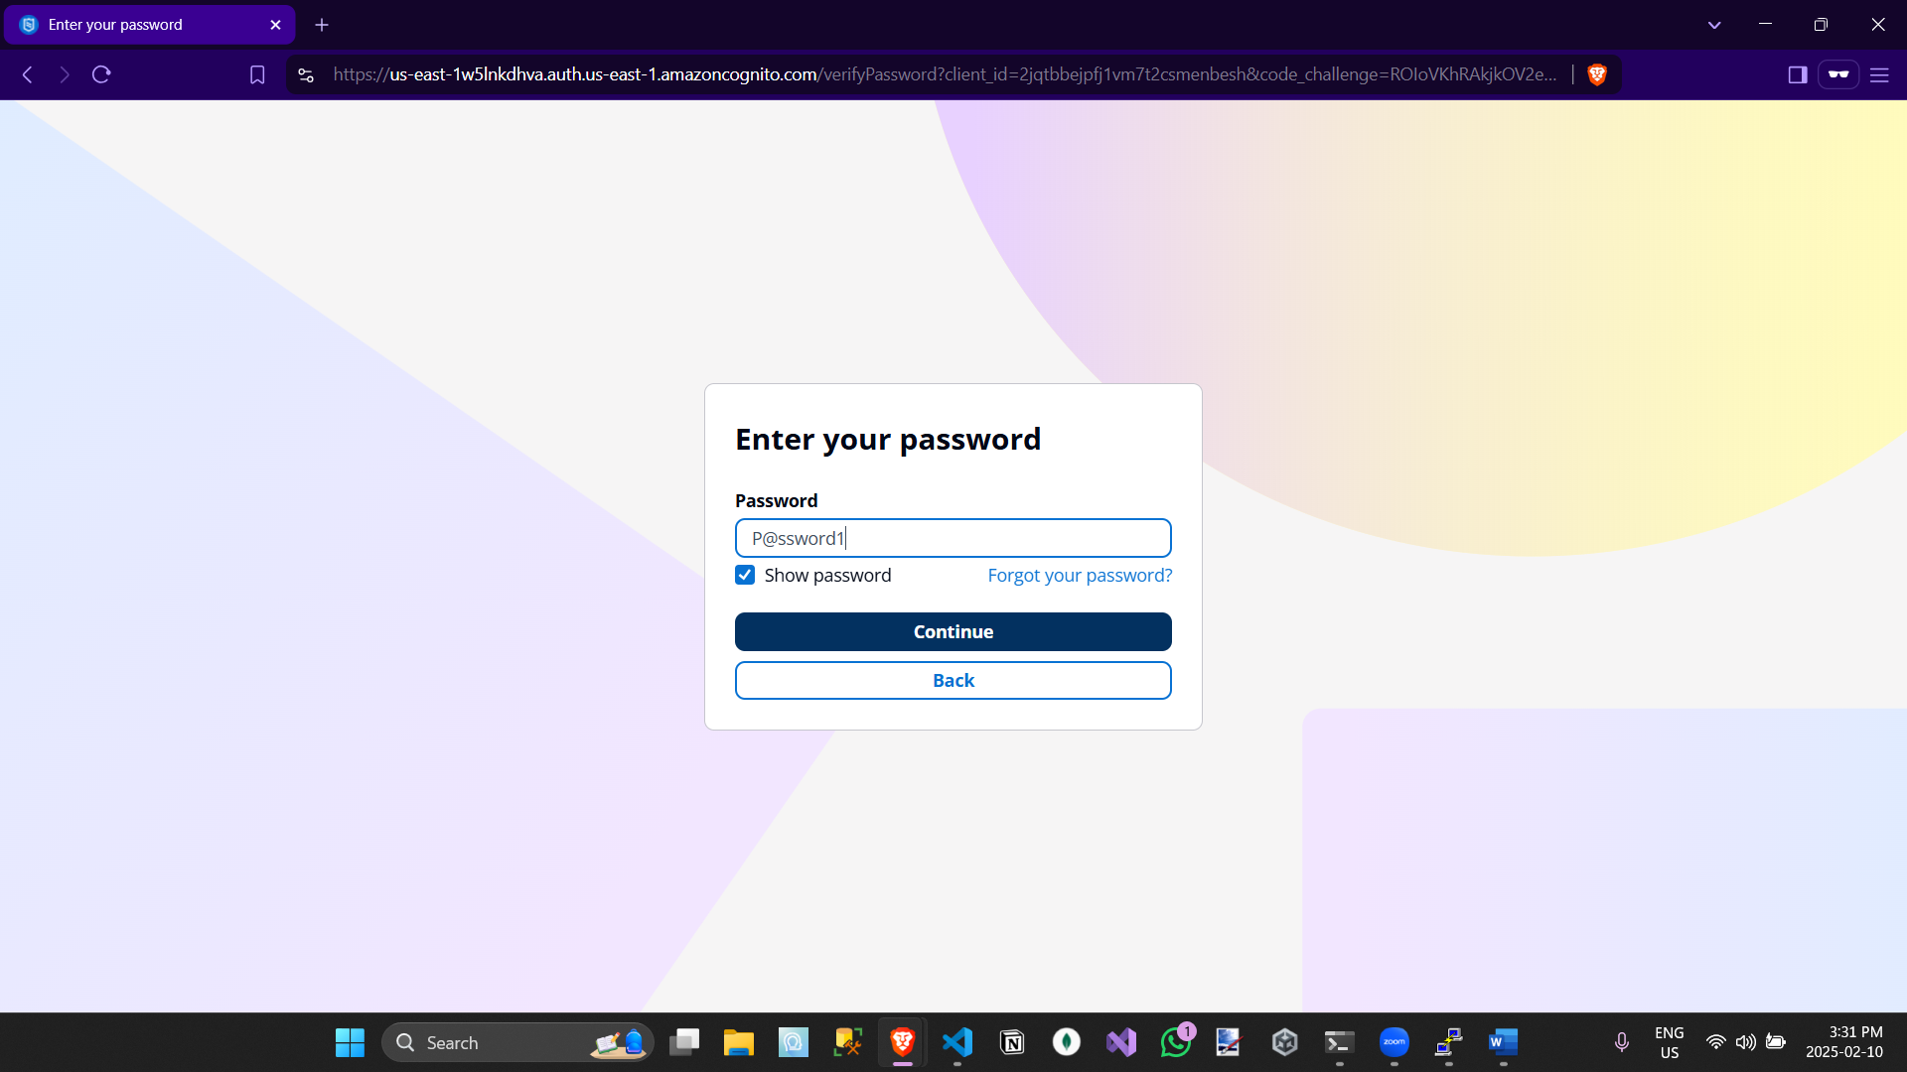
- After the user enters their username and clicks Next, they are sent here, still Cognito’s own Hosted UI, to enter their password and login.
4: Fragments UI running on localhost, creating fragment via HTTP POST, showing dev tools information
POST to the API server running EC2:
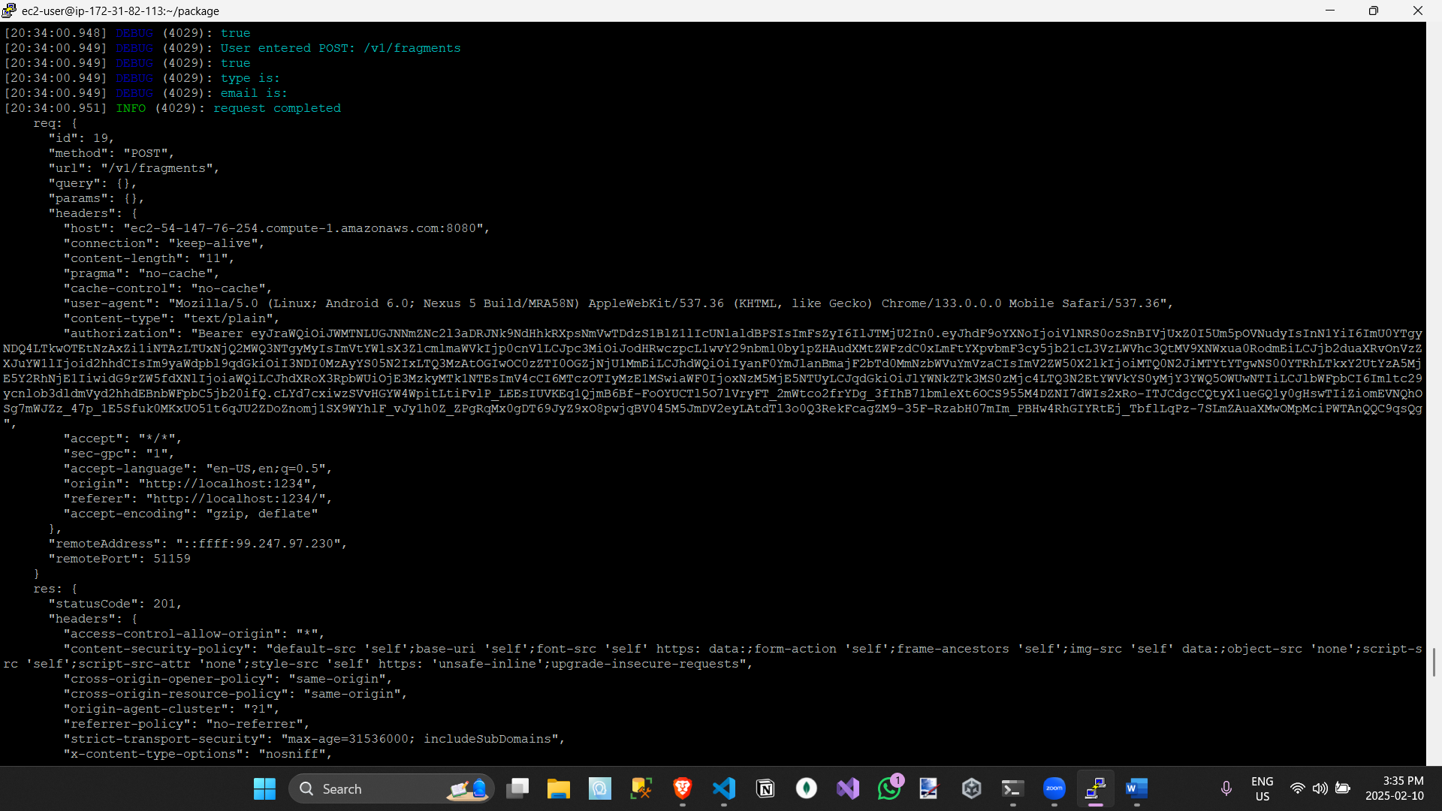
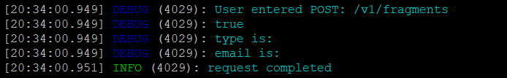
- After the user logs in, it sends a HTTP POST request to the EC2 Server, requesting them to make a fragment for this user. This shows that the request went through and was successful.
EC2 showing client enter GET /v1/fragments
(on next page)
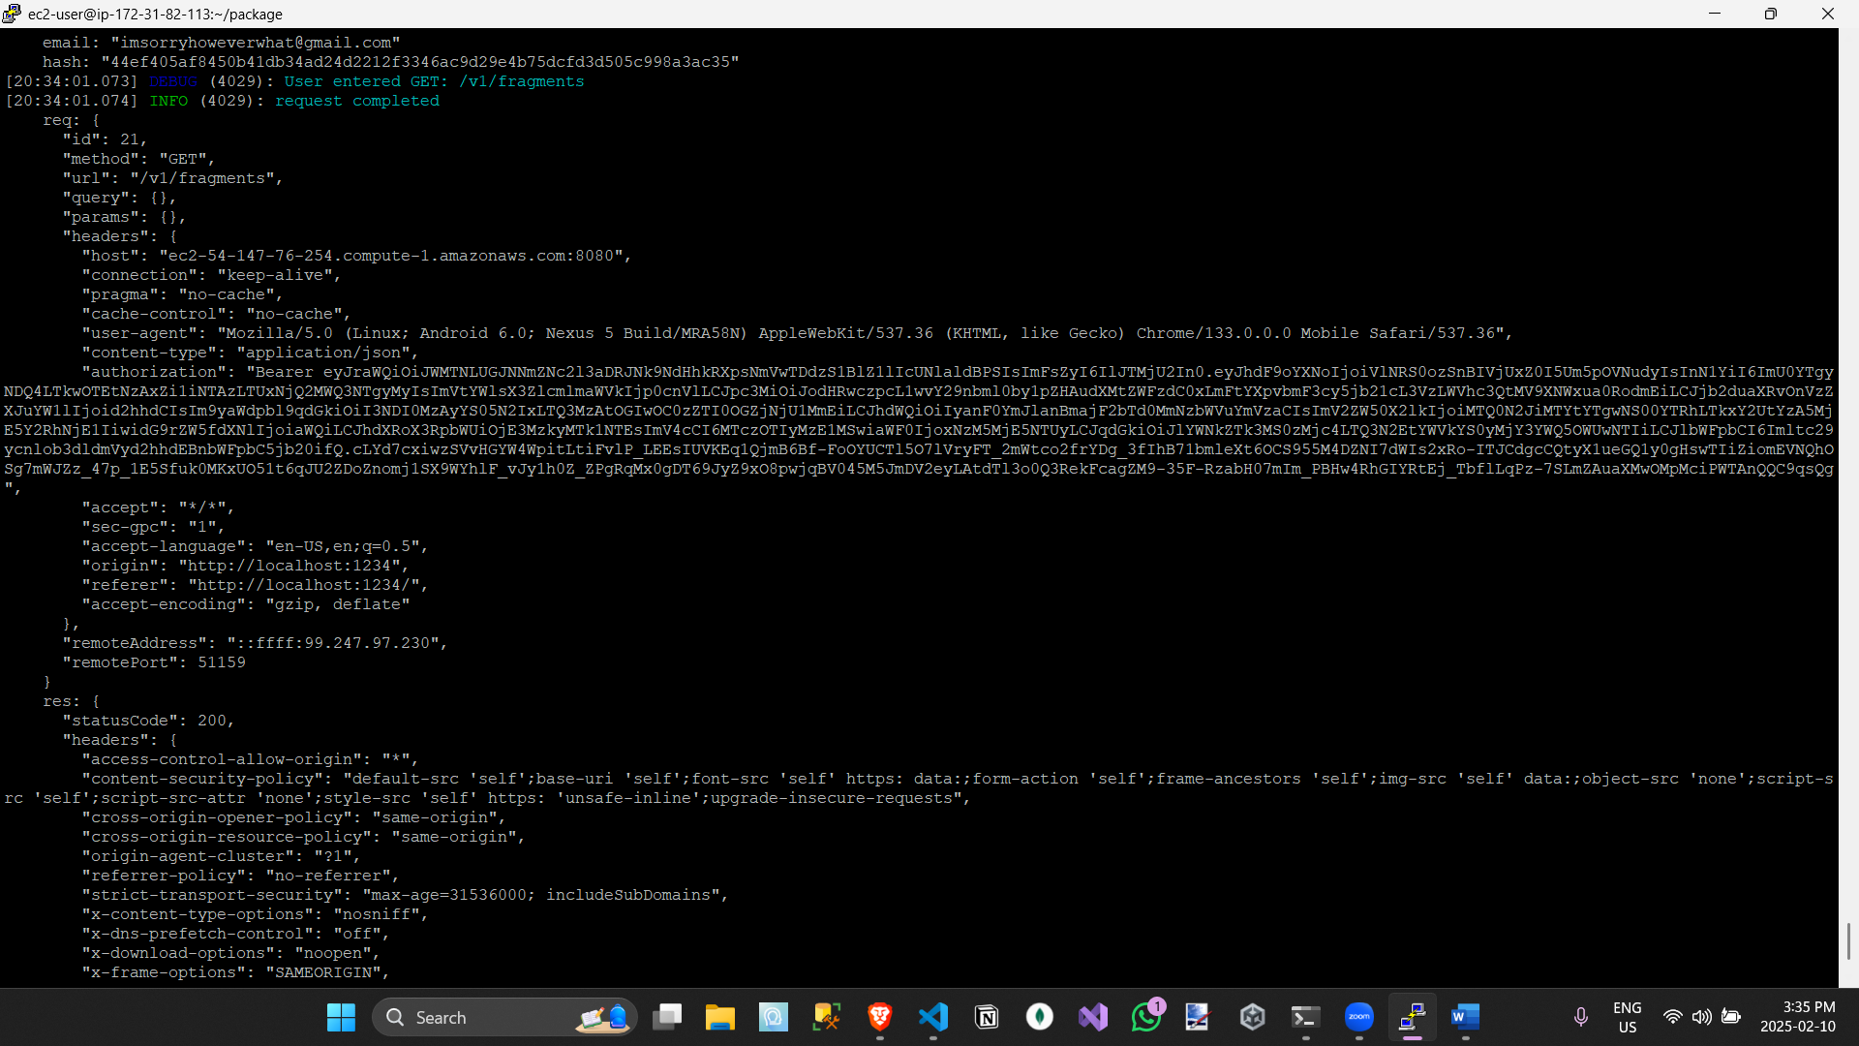
- Similarly to the previous one, this just shows the user requesting the GET v1/fragments from the EC2 instance. Also showing it was completed.
Network Response:
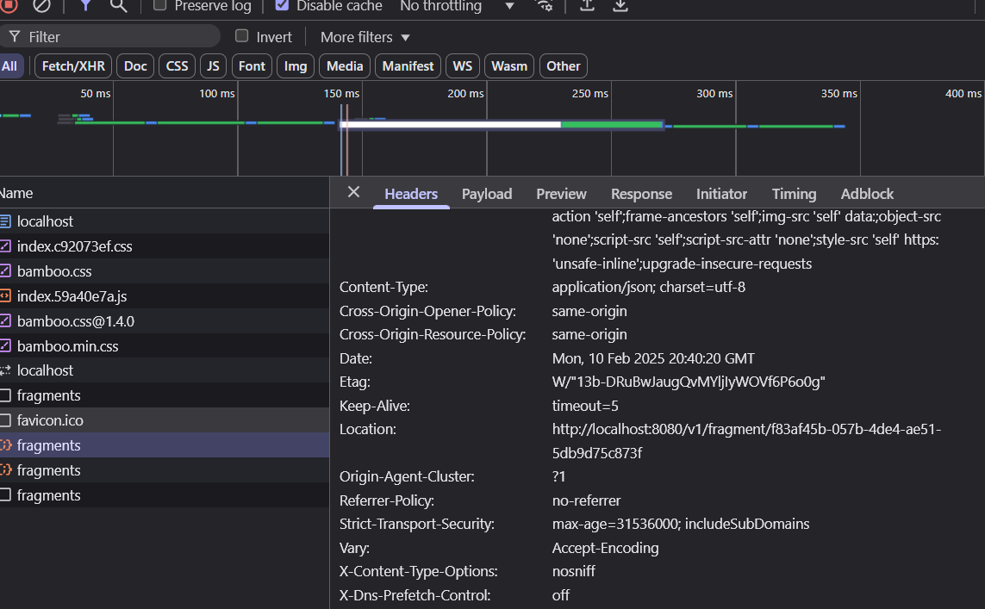
- This shows that in the Network Tab, the Location was added as a header to the fragments, showing that the EC2 microservice, added the Location as a header to the fragments UI
JSON MetaData:
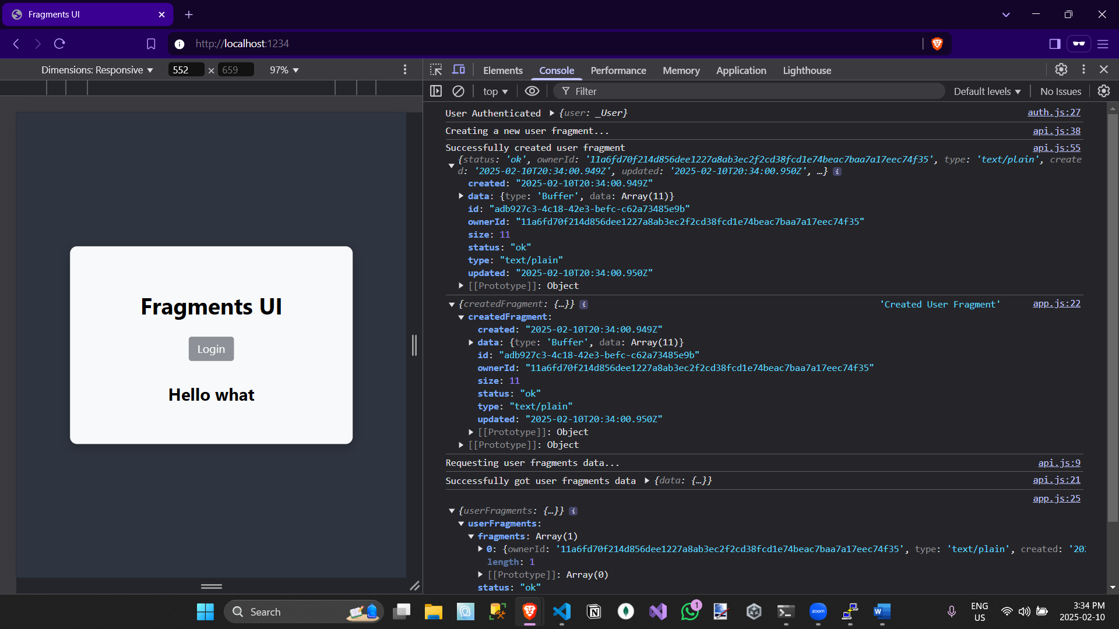
- This shows the JSON meta data returned from the EC2 instance. The first one, is the user object themselves, then you have the created fragment that was recently made, again then you have the recently created one, and then finally, you have the user’s getFragments response. The key to understanding was the log of, “Requesting user fragments data…”.
5: Coverage Report
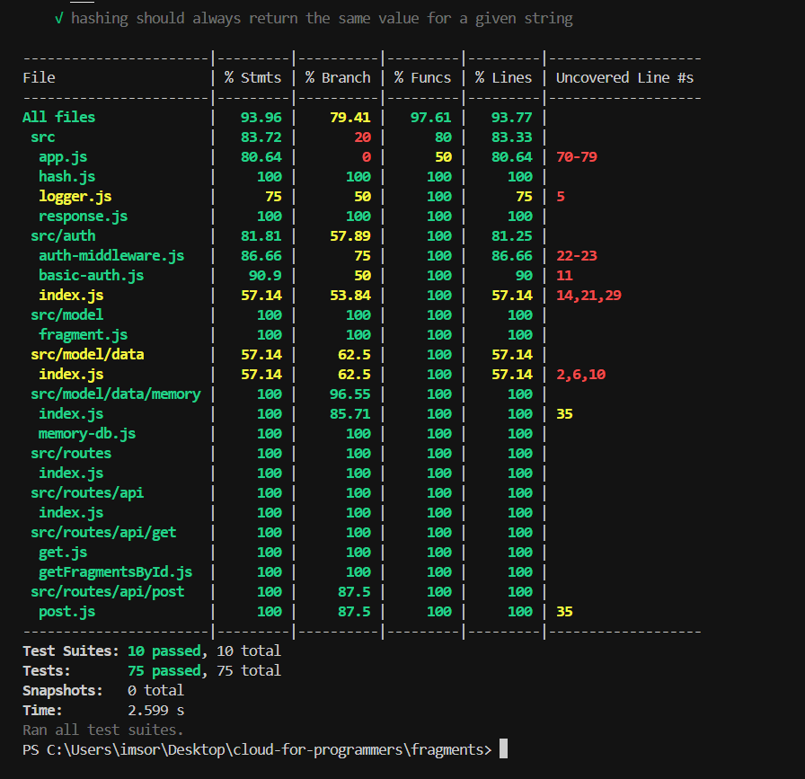
- This report shows how much of the microservice was tested
Conclusion:
Overall, the current state of the fragments microservice is a service where clients can login and be authenticated and authorized to create and access fragments. Currently, the client makes fragments and gets all their fragments or gets a specific fragment. In the future, a hierarchical authorization must be implemented, alongside the abilities to perform other CRUD operations, alongside conversions.

